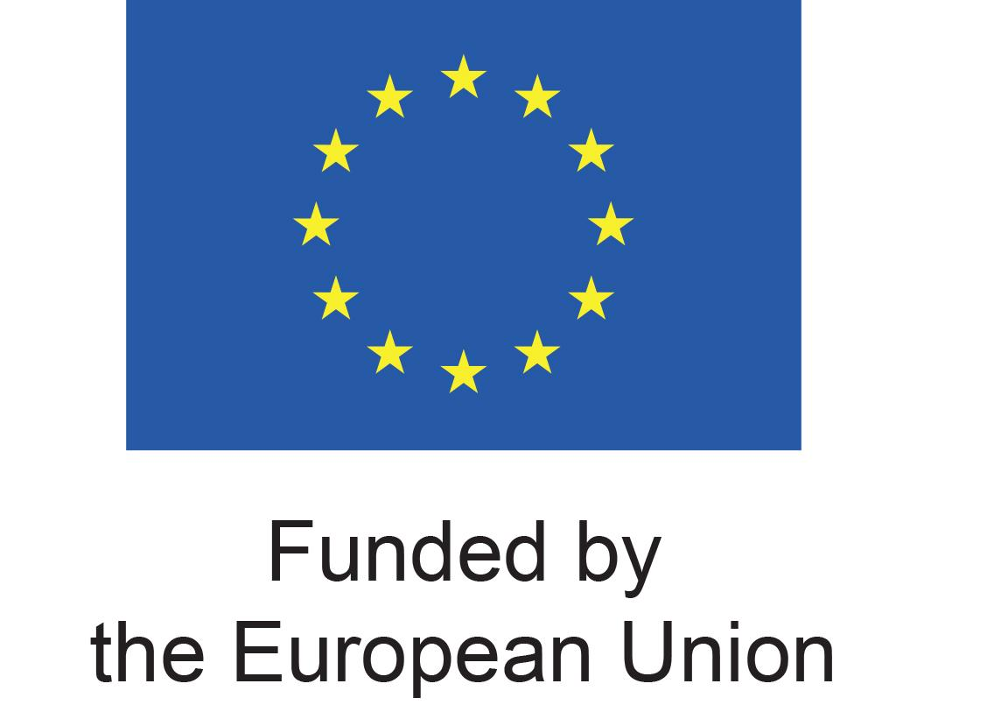
NATIONAL CONVENTION ON EUROPEAN INTEGRATION
Roundtable for Chapter 23 – Digital Services in Albania in the framework of negotiation process - DSA Governance, Fundamental Rights and Institutional Coordination
30 June 2026, 09:00 – 11:00
TBD, Tirana
The Electronic and Postal Communications Authority, in cooperation with European Movement Albania (EMA), is pleased to invite you to the next meeting of the Working Group for Chapter 23 - Judicial and the Fundamental Rights, organised in the framework of the National Convention On European Integration, supported by the European Union.

The Working Group for Chapter 23 provides a platform for consultation and dialogue, enabling the proactive involvement of non-state actors in Albania’s EU negotiation process. Participants include representatives of civil society, academia, legal professionals, and other relevant stakeholders. The roundtable aims not only to provide information on the legislative process, but also to ensure that civil society and interest groups are able to submit recommendations and actively follow and monitor policymaking throughout all stages.

As Albania rapidly aligns its legal framework with the EU acquis under the negotiation chapters, it continues to face a recurring implementation risk: European legislation may be formally adopted but remain weakly enforced or fail to produce positive effects in practice. This risk is particularly pronounced in the case of complex governance-oriented regulations such as the Digital Services Act (DSA), whose effectiveness depends not only on legal approximation, but also on institutional preparedness and sustained cooperation among public authorities, civil society, and the private sector. In this context, the focus of this roundtable will be the discussion of the harmonisation of Albanian legislation with the DSA, which provides for the regulation, coordination, and management of digital services offered by national and international operators, with the objective of standardising the regulation of digital service provision and strengthening the protection of users of such services, from the perspective of civil society and other non-state actors.

The roundtable takes place at a stage when discussions on the transposition of the DSA into Albanian legislation have gained increased attention, and where participation through information-sharing, dialogue, and the provision of recommendations is particularly important, especially regarding the protection of personal data, the guarantee of security in service provision, and the establishment of mechanisms safeguarding freedom of expression and access to information. This session will also present the experience of Slovakia and EU regarding the DSA, including the key findings of EMA’s policy research prepared by Slovak experts, with a focus on the Albanian case and the challenges of legal and institutional approximation.
We kindly invite you to confirm your participation at info@em-al.org.
We look forward to your contribution to this roundtable!
NATIONAL CONVENTION ON EUROPEAN INTEGRATION
Roundtable for Chapter 23 – Digital Services in Albania in the framework of negotiation process - DSA Governance, Fundamental Rights and Institutional Coordination
30 June 2026, 09:00 – 11:00
TBD, Tirana
08:45 – 09:00 | Registration of participants
09:00 – 09:20 | Opening of the Meeting  Gentian Sala, Chairperson, Electronic and Postal Communications Authority (AKEP)  Gledis Gjipali, Executive Director, European Movement Albania (EMA)
09:20 – 09:40 | Digital Services – Legislative Transposition Process: Information and Coordination  - The interconnection of the DSA with other horizontal developments and issues (GDPR, cybersecurity, media and freedom of expression, access to information, etc.)  - The need for capacities, infrastructure, and resources required for implementation – Coordinating structures and interinstitutional cooperation
 | Representative, Electronic and Postal Communications Authority (AKEP)
09:40 – 10:00 | Beyond Legal Harmonisation – How Is Digital Services Regulation Translated into Practice?  - What is the DSA – responsibilities, obligations, and innovations introduced for public institutions and non-state actors  - The role of the National Digital Services Coordinator – recommendations based on EU Member States’ experiences  - How these rules will affect different actors and sectors  - The role of CSOs and civil society in monitoring and protecting digital rights
 | Michaela Vanišová, Digital Citizenship Expert, DigiQ Slovakia
10:00 – 10:30 | Interactive Discussion  With representatives of civil society, legal professionals, media, interest groups, and the business community
10:30 | Closing of the Event and Coffee

